B.C.M. Sen. Sec. School, Basant City, Pkh. Road, Ludhiana.
Name ___________________ Roll No._____ Standard II
Chapter ( Introduction To Computers )
- Essay on ‘My Computer’
- I have a computer.
- My computer is a machine.
- It works with electricity.
- It works very fast.
- It never gets tired.
- It cannot work on its own.
- It needs my order to work.
- Answer the following questions:
- What is a computer?
Ans. Computer is an electronic machine.
- List any four uses of a computer.
Ans. Play games, watch movies, solve sums, and draw pictures.
- Give any two advantages of a computer over a human being.
Ans. 1. It never makes mistakes.
2. It does not take rest.
- Which type of computers is big and cannot be moved?
Ans. Desktop computers
- Name two types of computer having touchscreen to work on it.
Ans. Tablet, Smartphone
- Fill in the blanks:
- Computer needs our instructions to work.
- The word computer comes from the word compute.
- Scanner is used to put pictures into the computer.
- Rolltop computer has a screen which can be rolled up.
- Smartphone can be used as a computer as well as mobile.
- Printer helps to take the work on a paper.
- State T for true statement and F for false statement:
  - You can make drawings using a calculator.
  - Both man and computer need care to work properly.
  - Speakers are used to record sound in computer.
  - Laptop computer works on battery.
  - PC stands for private computer.
  - Computer follows three steps.
- Identify the following pictures and write their names. Also colour them.
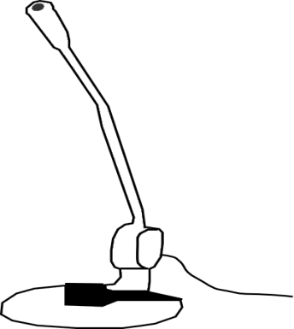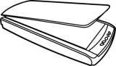
__________________________ ________________________ __________________________
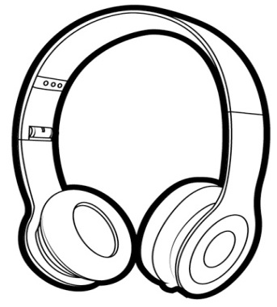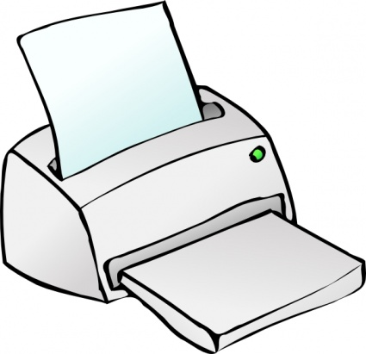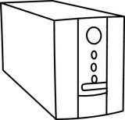
__________________________ ________________________ __________________________
- Match the following to their names.
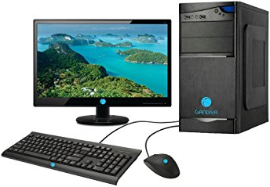 | Laptop Computer
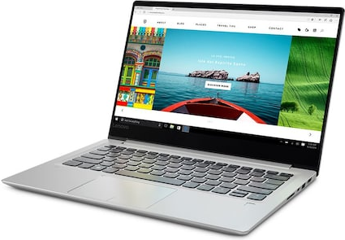 | Smartphone
 | Tablet
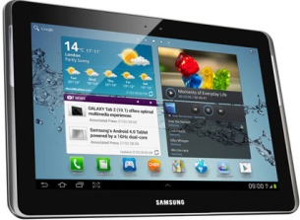 | Desktop Computer

